Here we will add navigation bar. First we use nav element of html. This element is used for displaying navigation bar. Now bootstrap works with classes. To style this navigation bar we apply class **navbar** on it. then we add some links inside this nav bar. To first link we add a class **navbar-brand**. This makes sure that this link is styled and positioned in a nice way on top left corner of navigation bar, where you generally have your brand, which takes you to your home page.

<nav class="navbar">

<a class="navbar-brand" href="#">Academind</a>

</nav>

In browser-

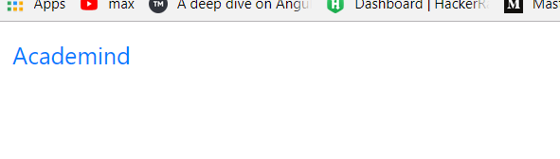

We only see link, navigation bar is not visible. We need to add more classes to nav element. We add **navbar-light** to set theme and **bg-light** to set background theme. Now we see navigation bar, taking full width on screen.

<nav class="navbar navbar-light bg-light">

<a class="navbar-brand" href="#">Academind</a>

</nav>

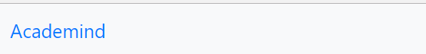

navbar-light changes the color of link(or brand), color to navigation bar is given by **bg-light**.

Now we only have brand in our navigation bar. It is like a home button, which leads us back to home page. Now we want to have more in navbar than just a brand , we want to have clickable items. So we added <ul>. To this we give a class- **navbar-nav** to indicate that this contains our menu items. Then we add items using <li>. This li also receives a class **nav-item.** Under <li> we have <a> tag with another class. So this is structure we typically set up for menu items in navigation bar.

<nav class="navbar navbar-light bg-light">

<a class="navbar-brand" href="#">Academind</a>

<ul class="navbar-nav">

<li class="nav-item"><a href="#" class="nav-link">Users</a></li>

</ul>

</nav>

Our users link is nicely placed on extremely right of page. This is done automatically for you by bootstrap. To change that add **mr-auto** (margin-right auto)class to ul. Now this menu item will be positioned on left instead of right. Since bootstrap uses flexbox this automatically leads to this positioning. Inspect <ul> in chrome dev tool-

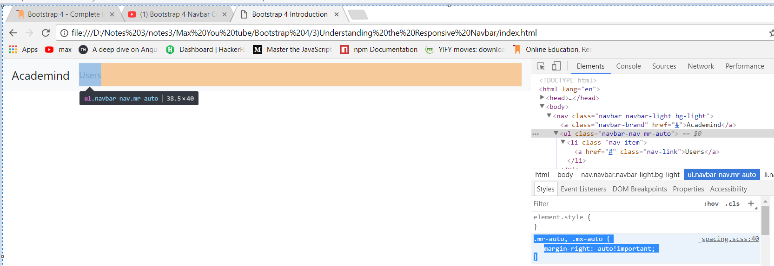

Now with margin-right set to auto, it actually fills all the space with this margin to right and hence this <ul> with all its items is pushed to left. If we remove this **mr-auto** class in chrome dev tools (just unselect it), then menu items are gain pushed to right. This is how navbar works. now inspect <nav> elemnt in chrome dev tools. We applied **navbar** class o it. This class has this styles-

display: flex

and then it positions its elemnts by, space between-

justify-content: space-between;

so mr-auto is nice way of moving elements to left. We wnt use it here. We want to have this space-between. Lets dive deeper lets add more items to our menu. Lets more <li> items.

<ul class="navbar-nav ">

<li class="nav-item"><a href="#" class="nav-link">Users</a></li>

<li class="nav-item"><a href="#" class="nav-link">Products</a></li>

</ul>

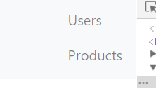

But it adds new line instead of adding it beside first list item. Why is that? Inspect <ul> with **navbar-nav** class in chrome dev tools. Here we can see that-

flex-direction: column;

so here we can see that flex-direction is column insetad of row. this is not a bug,this on purpose , because bootstrap 4 is build in a mobile first way. Because of this mobile first approach we can also build our navigation bar in mobile first way. To do this we add div , with following class-

<div class="collapse navbar-collapse"></div>

This div then wraps <ul> element. If we place <ul> in it, then all our menu items are gone. This is because now we need to tell bootstrap how long or from which point on ,we actually want to render our menu items in navbar instead of in a toggable dropdown menu. We do this by adding **navbar-expand** class to <nav> element. then we set a breakpoint , defining from which point on should elements should be added to navbar. This could be **lg** to only add them on big screens for example. Code-

<nav class="navbar navbar-expand-lg navbar-light bg-light">

<a class="navbar-brand" href="#">Academind</a>

<div class="collapse navbar-collapse">

<ul class="navbar-nav ">

<li class="nav-item"><a href="#" class="nav-link">Users</a></li>

<li class="nav-item"><a href="#" class="nav-link">Products</a></li>

</ul>

</div>

</nav>

Now this menu items are only added to bigger screens. On smaller screen these are not added. Now these are added on left instead of right.



Now if you want to move them to right, add **ml-auto** class to <ul>. This class adds margin to left to move our items back to right. But we will with default setup.

Now menu items are removed, if we go below certain size and ofcourse we can change that breakpoint. Instead of lg we can also use sm, now menu items will disappear on small devices. Now question is how do we bring them back for smaller devices. They disappear may be because we are running out of space in navigation bar, but where do we then display them? Well in some extra menu which can be toggled, the problem is we got no toggle button. We can add to navbar that bootstrap offers us. We add this button after brand, we can also add in front of it. We also give it a class. Now in this button we do not write anything, you simply give it a span and give it a toggle-icon class. This will give you hamburger menu in the end. Code-

<nav class="navbar navbar-expand-sm navbar-light bg-light">

<a class="navbar-brand" href="#">Academind</a>

<button class="navbar-toggler">

<spna class="navbar-toggler-icon"></spna>

</button>

<div class="collapse navbar-collapse">

<ul class="navbar-nav ">

<li class="nav-item"><a href="#" class="nav-link">Users</a></li>

<li class="nav-item"><a href="#" class="nav-link">Products</a></li>

</ul>

</div>

</nav>

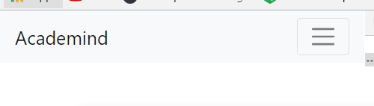

Now this toggle icon will be removed when we increase the size and we get menu items. But now clicking the button is not doing anything. That has 2 reasons-

1. We need to add something to button to make it work, it is **data-toggle** property or attribute I should say, we set it to collapse. It would be used by bootstrap’s js package, it will automatically listen to clicks on button then and it will open menu for us and close it if it is open, all of that done automatically.

Now problem is even with this property added nothing happens on click of this button. Reason is we have not included the bootstrap script packages, so lets add them. Where we found cdn for css, we also find cdn for js. Copy those imports and add them after <body> tag in index.html. we we run code gain, nothing happens when we click on button.

Well there is another missing piece. We added data-toggle attribute on button, which will lead to listener being setup but we also need need to setup **data-target** attribute which points at the element, the menu that we want to toggle. There we use a css selector, recommended is to use id. Then we need to give that id to div which wraps our <ul>

Code-

<nav class="navbar navbar-expand-sm navbar-light bg-light">

<a class="navbar-brand" href="#">Academind</a>

<button class="navbar-toggler" data-toggle="collapse" data-target="#navbarMenu">

<spna class="navbar-toggler-icon"></spna>

</button>

<div class="collapse navbar-collapse" id="navbarMenu">

<ul class="navbar-nav ">

<li class="nav-item"><a href="#" class="nav-link">Users</a></li>

<li class="nav-item"><a href="#" class="nav-link">Products</a></li>

</ul>

</div>

</nav>

Now we can see that on click , menu appears. This is how you add basic navbar to your project. At the end of lecture you can see that there is link to official docs, where you can dive deep and see how to add search bar. Link-

<http://getbootstrap.com/docs/4.0/components/navbar/>

One thing that I want to show is , how you can set different color schemes for this navbar. Right now we are using light scheme here with, classes

navbar-light bg-light

applied to nav element. We can use **navbar-dark and bg-dark** to get dark scheme.

